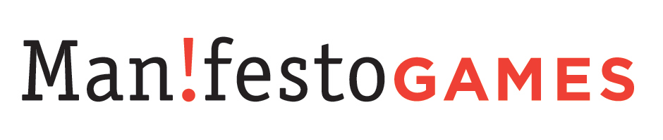
355 South End Ave #2B
New York, NY 10280
http://www.manifestogames.com
V: (646) 489 8609
F: (646) 349-1953

Dear Sir or Madam:

This non-binding Letter of Intent is to express that Manifesto Games, Inc. is very interested in working with Corbomite Games in bringing their Zbang game to market. Manifesto Games is an online aggregator, marketer, and retailer of PC games aimed at core gamers, and we believe that Corbomite's product is commercially viable and likely to appeal to our audience.

Regards,

Greg Costikyan
CEO, Manifesto Games
greg@manifestogames.com

